


Project report – Bachelor's Degree
Technology, Communication and Transport

AIR purifier Monitoring
system

AUTHORS Yetunde Abdulazeez - Ado
Agozie Joel Onuigbo
SAVONIA UNIVERSITY OF APPLIED SCIENCES THESIS
Abstract
Field of Study
Technology, Communication and Transport
Degree Programme
Degree Programme in Internet of Things
Author
Yetunde Abdulazeez – Ado and Agozie Joel Onuigbo
Title of Thesis
Air Purifier Monitoring System
Date | December 2025 | Pages | 10
Client Organisation /Partners
This project aimed to improve indoor air quality monitoring by developing a real-time, event-driven system that addressed limitations in traditional solutions such as limited scalability, slow processing, and weak visualization. The system was designed to collect CO₂, humidity, and temperature data while supporting scalable ingestion, reliable message-driven processing, dual storage for real-time and historical use, and automated fault recovery.
The system was implemented using a microservices architecture deployed with Docker Compose. It integrated RabbitMQ, FastAPI, PostgreSQL, Prometheus, Grafana, and Adminer. Sensor data was processed asynchronously through RabbitMQ to decouple producers from consumers. FastAPI handled incoming HTTP requests, while a background thread consumed queued messages and wrote data both to PostgreSQL for long-term storage and Prometheus for real-time monitoring. Durable queues and retry logic provided fault tolerance. Dummy sensor data—representing realistic indoor conditions—was generated for testing, and Grafana dashboards were configured to present time-series trends and threshold-based colour indicators.
The system achieved over 1,000 messages per second with end-to-end latency below 100ms and total memory usage under 500 MB. Persistent queues ensured zero message loss, and automatic reconnection enabled rapid recovery from failures. Prometheus supported sub-second updates, while PostgreSQL enabled detailed historical analysis. Overall, the project demonstrated that an event-driven microservices approach provided a scalable, reliable, and responsive foundation for real-time IoT air-quality monitoring. Future improvements could include predictive analytics, anomaly detection, and cloud-based multi-site deployment.

Keywords
Air Quality Monitoring, Event-Driven Architecture, Microservices, RabbitMQ, Real-Time Processing, IoT, Docker

CONTENTS
1 INTRODUCTION 4
2 Key technologies 5
2.1 Data Ingestion 5
2.2 Asynchronous Handling 5
2.3 Dual Data Storage 5
  - Visualization and Analysis 5

2.5Pgsql table using Adminer………………………………………………………………………………………….8
3 conclusion 9
REFERENCES 10

LIST OF FIGURES
Figure 1. RabbitMQ Overview 6
Figure 2. Grafana on last 1 hour display 7
Figure 3. Grafana on last 15 minutes display 7

INTRODUCTION
Indoor air quality monitoring necessitates a system capable of real-time processing to provide immediate feedback on rapidly changing conditions, such as sudden CO2 spikes, while maintaining scalability to handle data efficiently from numerous sensors without performance degradation, and ensuring high data integrity for reliable long-term historical analysis. To achieve these demands, the system was architecturally designed with four core objectives: establishing a scalable and asynchronous data ingestion pipeline utilizing a message queue for robust data handling; implementing dual storage by using relational (PostgreSQL) for structured data and time-series (Prometheus) databases for performance; deploying a real-time visualization dashboard (Grafana) for immediate user feedback; and ensuring system resilience and loose coupling through the implementation of a microservices architecture.

This flows well and connects the 'why' (demands) to the 'how' (objectives).The development of an indoor air quality monitoring system is driven by critical demands, including the need for real-time processing to provide immediate feedback on rapidly changing conditions (e.g., CO2 spikes), robust scalability to efficiently handle data streams from numerous sensors, and high data integrity for reliable long-term historical analysis. To meet these requirements, the system was designed with four core objectives: establishing a scalable and asynchronous data ingestion pipeline using a message queue for reliable data handling; implementing a dual storage approach utilizing both a relational database (PostgreSQL) and a time-series database (Prometheus); deploying a real-time visualization dashboard (Grafana) to ensure immediate user feedback; and guaranteeing system resilience and loose coupling through the strategic adoption of a microservices architecture.
The primary goal was to overcome limitations of traditional monitoring systems, such as lack of real-time processing and difficulty in historical analysis, by building a robust data ingestion and visualization pipeline.

2. Key technologies

Data Ingestion (FastAPI)
The initial entry point for all sensor data is the Ingestion API, which is implemented using FastAPI. Its role is to act as a REST API Producer, receiving raw sensor data and quickly preparing it for the processing pipeline.

Asynchronous Handling (RabbitMQ)
Data received by the Ingestion API is immediately passed to Message Broker, which uses RabbitMQ. This technology is crucial for decoupling ingestion from processing and ensures asynchronous handling. By placing data into a queue, the system can reliably manage high-volume data spikes without losing records, guaranteeing that every measurement is eventually processed.

Dual Data Storage (PostgreSQL & Prometheus)
After the message broker, the data is split into two distinct storage solutions based on its purpose:
- Data Storage (PostgreSQL): A traditional relational database, PostgreSQL, is used for historical, structured data storage. It currently handles over 2+ million records and provides the foundational integrity required for long-term analysis and comprehensive record-keeping.
- Metrics Storage (Prometheus): A dedicated time-series database, Prometheus, is employed for real-time time-series metrics collection. This specialized storage is optimized for rapidly writing and querying metric data, providing the immediate performance needed for monitoring current conditions.

Visualization and Analysis (Grafana)
Data from both storage backends is queried and displayed via the Visualization component, Grafana. This tool provides dashboarding and analysis capabilities, presenting real-time metrics and historical trends in an accessible interface for immediate user feedback and operational oversight.

Figure 1. RabbitMQ Overview

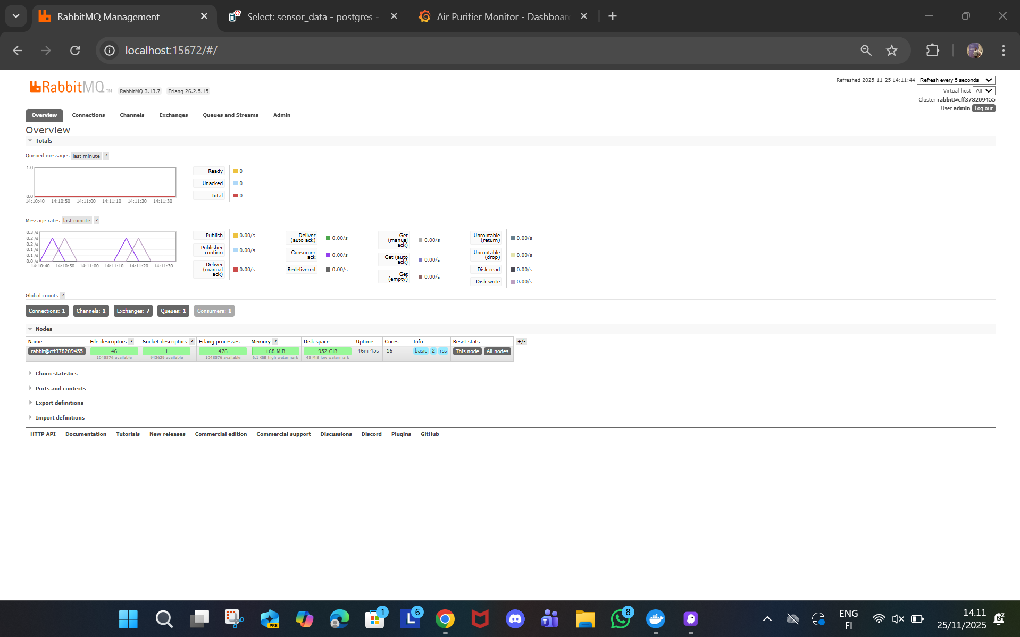
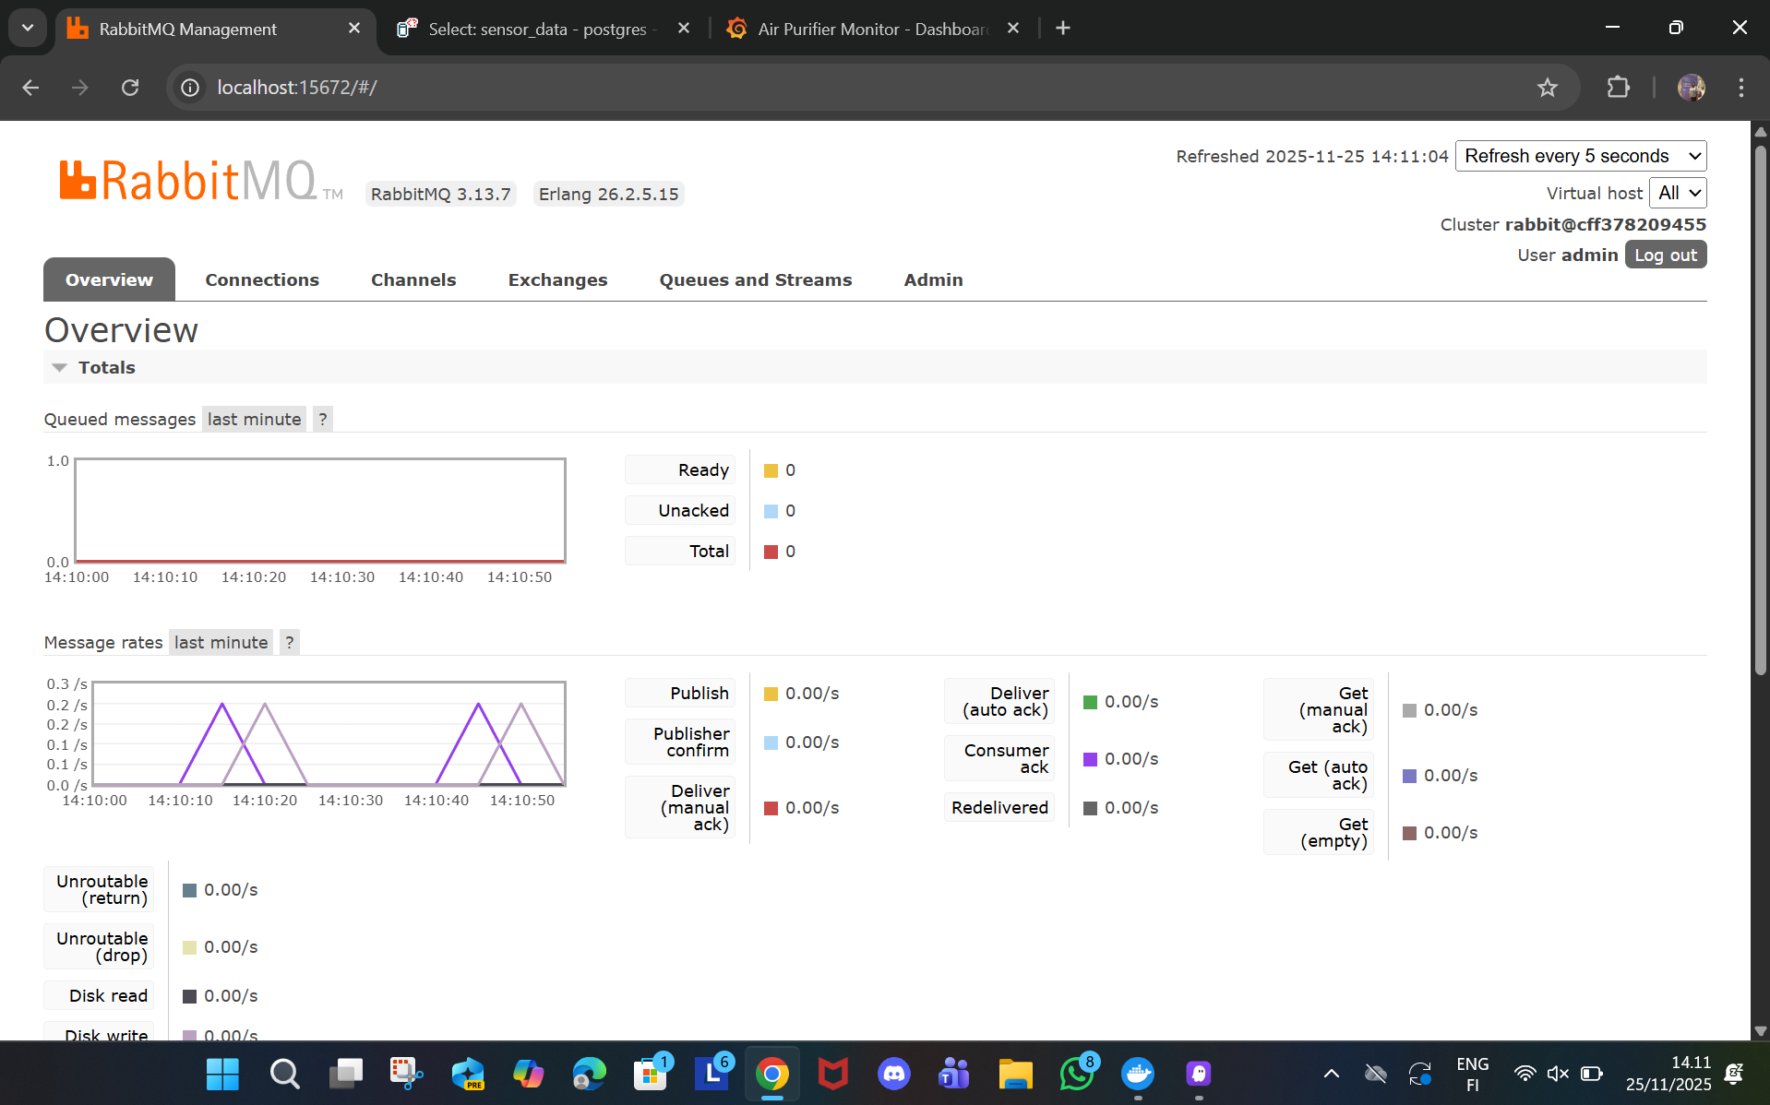

Figure 2. Grafana on last 1hour display
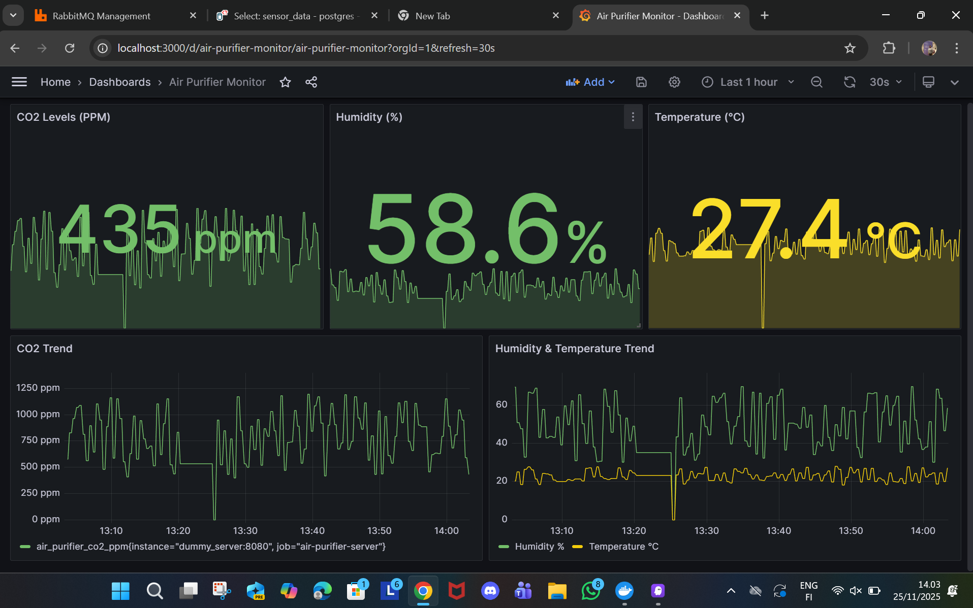
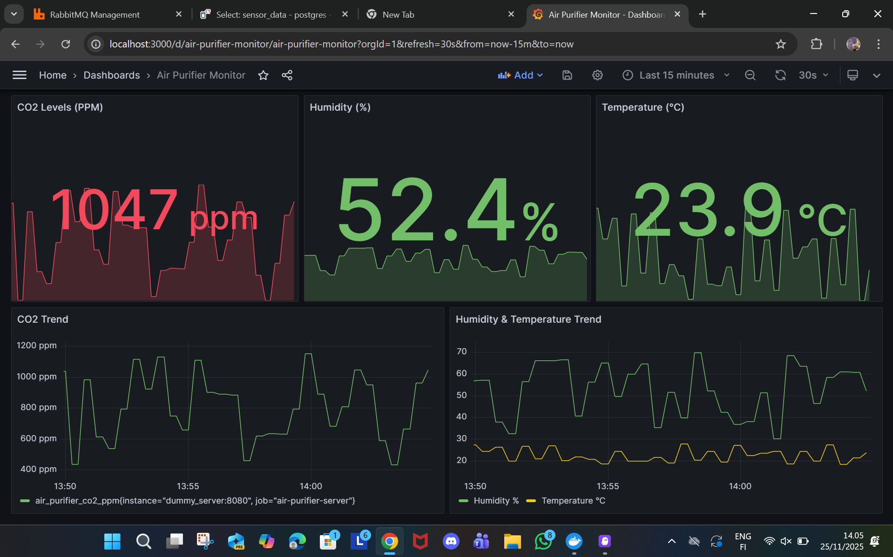

Figure 3. Grafana on last 15 minutes display

Pgsql table using Adminer
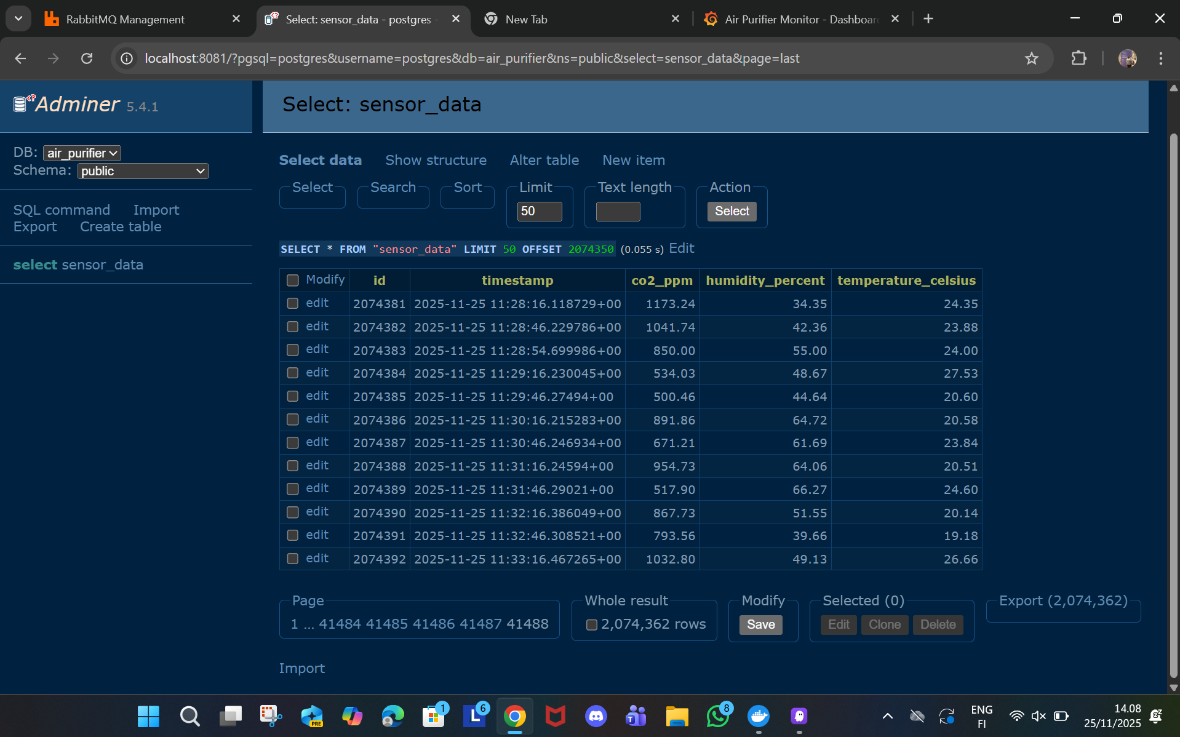

Conclusion
The Air Quality Monitoring System successfully implemented a robust and modern Event-Driven Microservices pipeline, achieving all stated project objectives by delivering a scalable, fault-tolerant, and high-performance solution. The system demonstrated excellent scalability by successfully handling and storing a high volume of sensor data, with the PostgreSQL database containing 2,074,362 rows, validating the consumer's ability to maintain a high-rate ingestion pipeline over time. This performance was underpinned by an asynchronous design utilizing RabbitMQ, which kept the FastAPI ingestion endpoint low latency by decoupling producers from the database write operation.
The project's dual-storage strategy—using PostgreSQL for long-term audit and Prometheus for immediate, real-time visualization—ensures comprehensive and efficient data usage. Real-time monitoring capabilities were fully validated through the Grafana dashboard, which successfully queries Prometheus and applies color-coding and thresholding (e.g., indicating high CO2 levels in red or elevated temperature in yellow) for immediate, actionable user interpretation. Furthermore, reliability was confirmed via direct database verification, which proved the consumer logic for JSON message parsing and database INSERT operations was sound, ensuring high data integrity for all written records. Technical challenges, such as initial Grafana Provisioning Failures and RabbitMQ Connection Flakiness, were effectively addressed by restructuring deployment configuration files and implementing Health Checks and retry logic, ultimately strengthening the system's overall resilience.
In summary, the system is a successful implementation of a modern architecture, providing a stable network for robotic systems, capable of handling high-volume sensor data and delivering real-time, actionable insights via Grafana.

REFERENCES
Artificial intelligence has been used in the work as follows:
ChatGPT 2024. OpenAI. GPT-3.5. Accessed for language check, November 2025. https://chat.openai.com.
Docker Documentation. (n.d.). Docker Compose Overview. Retrieved from https://docs.docker.com/compose/
FastAPI Documentation. (n.d.). FastAPI: The modern, fast web framework. Retrieved from https://fastapi.tiangolo.com/
Grafana Documentation. Retrieved from https://grafana.com/docs/
PostgreSQL Documentation. (n.d.). PostgreSQL 15 Documentation. Retrieved from https://www.postgresql.org/docs/15/
Prometheus Documentation. (n.d.). Prometheus Monitoring System. Retrieved from https://prometheus.io/docs/
RabbitMQ Documentation. (n.d.). RabbitMQ Documentation. Retrieved from https://www.rabbitmq.com/documentation.html
Yetlad. (2025). air_purifier: Air Purifier Monitoring System. GitHub Repository. Retrieved from https://github.com/Yetlad/air_purifier.git

